These are beta screenshots that explain some plus patch restorations.

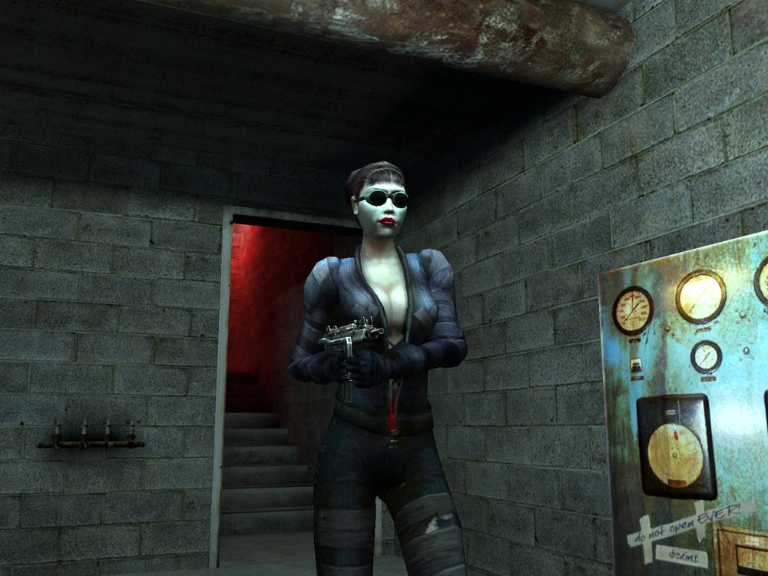
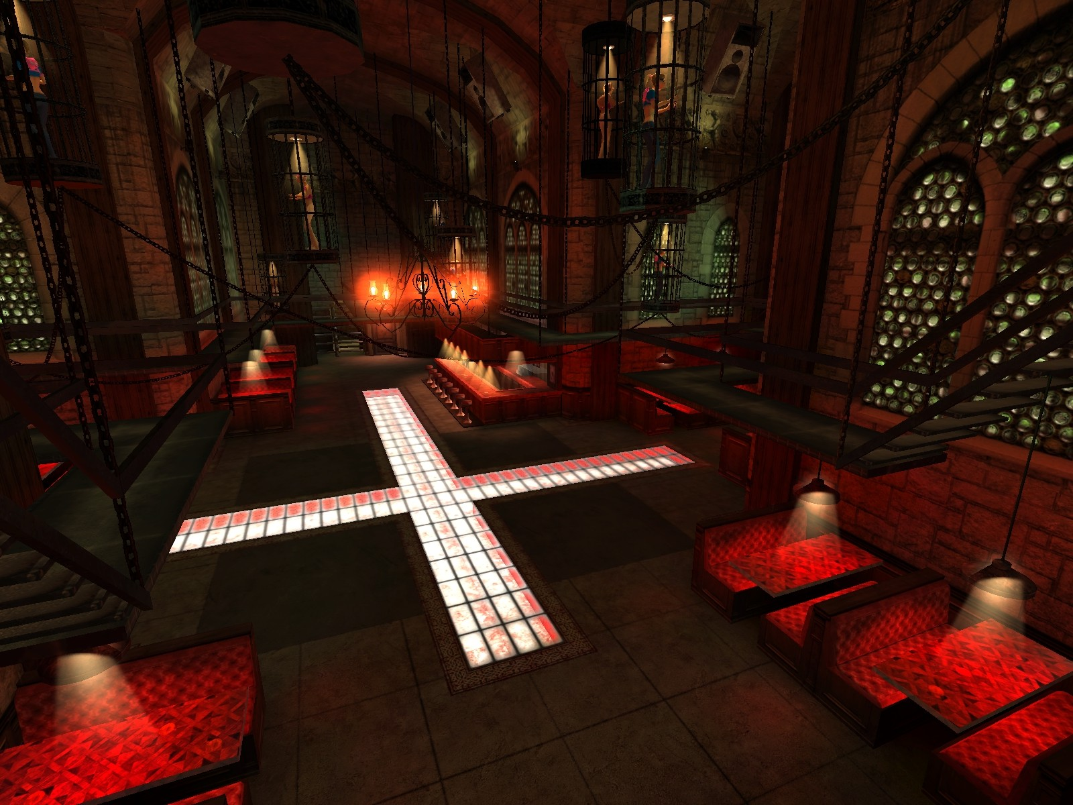

1. Electric box at Ocean House. 2. Cage dancers at Confession.

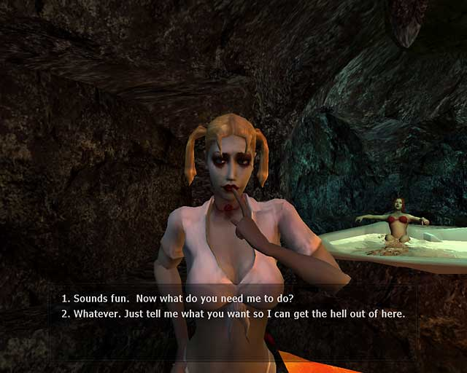
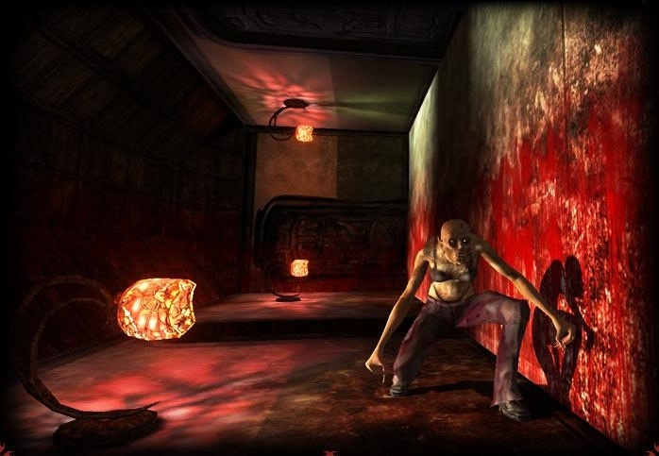

3. Girl in pool of Vesuvius. 4. Grout's mansion maze room.
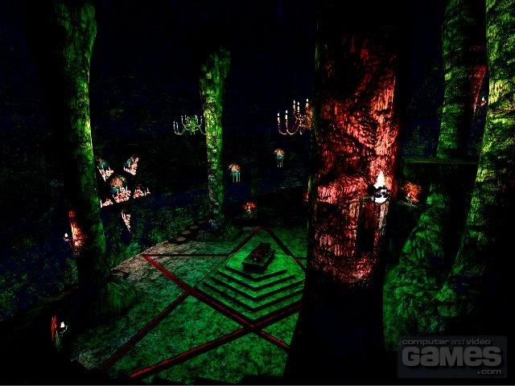

5. Ritual chamber at library.

